Description of Area Covered by the Strategy
Map 1 shows the location of Bulkley, Kispiox and Cassiar Timber Supply Areas within British Columbia, and the extent of their timber harvesting landbases (THLB).
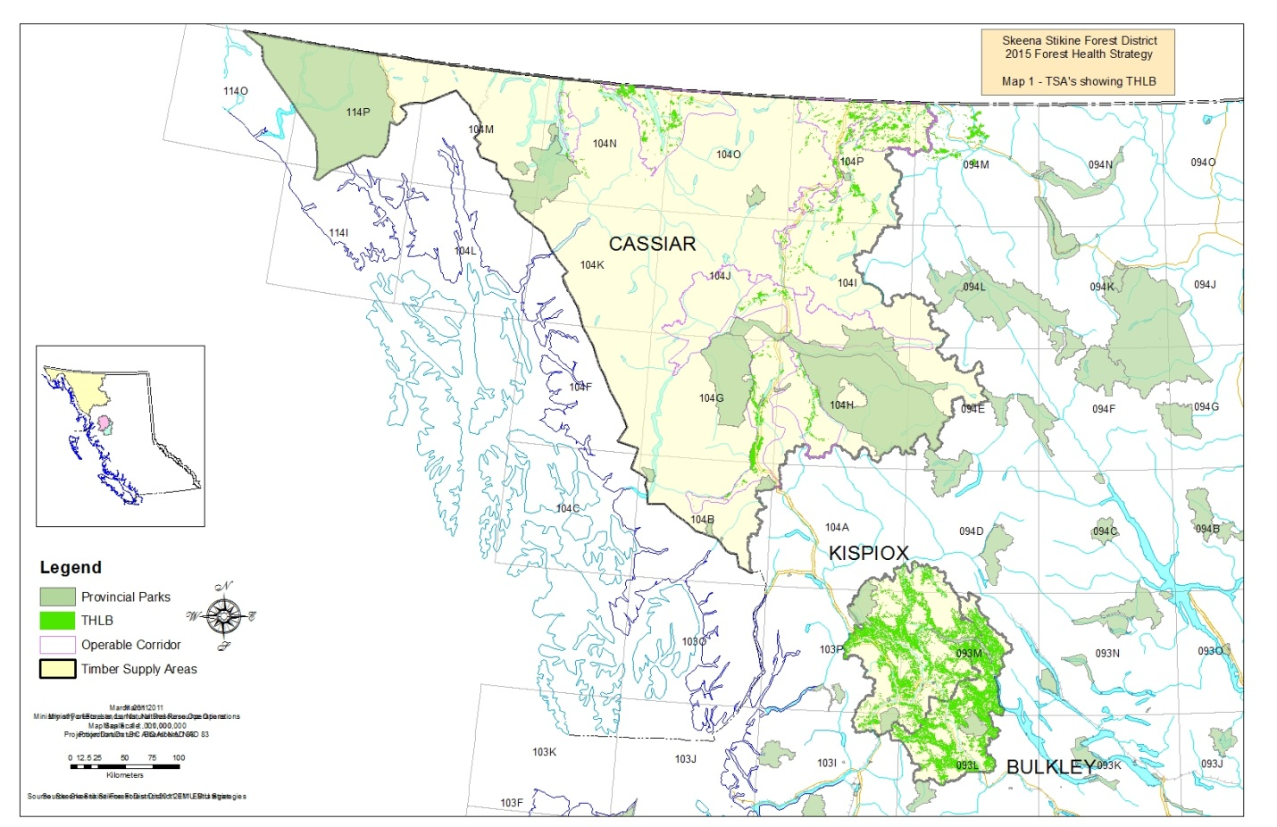
The 763,000 hectare (Ha) Bulkley Timber Supply Area (TSA) transitions coastal and interior climates and is ecologically diverse. Topography ranges from flat or rolling to mountainous. Major rivers include the Bulkley and Babine, and Babine Lake is to the east.
Sub-Boreal Spruce (SBSmc2, dk) and Engelmann Spruce-Subalpine Fir (ESSFmc, wv) biogeoclimatic zones dominate. Small areas of Interior Cedar-Hemlock (ICHmc2), Coastal Western Hemlock (CWHws2), and Mountain Hemlock (MHmm) biogeoclimatic zones are also present.
The CFLB (500,000 Ha) and the THLB (283,500 Ha) are dominated by subalpine fir, lodgepole pine, spruce, and western and mountain hemlock. Natural stands are mostly older than 100 years, and managed stands are under 45 years.
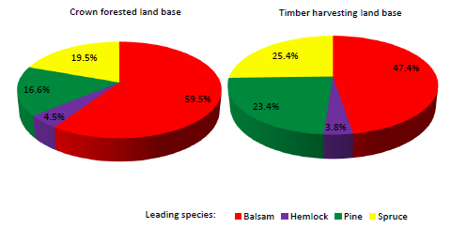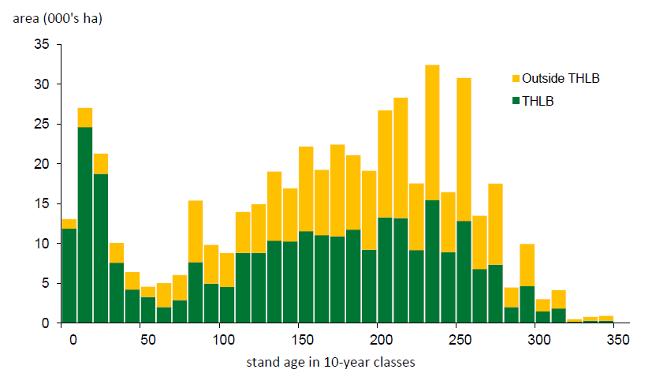
The 1.22 million Ha Kispiox TSA also transitions coastal and interior climates. Topography is mountainous, with a mix of wide and narrow forested drainages between ranges. Major rivers include the Skeena, Bulkley, Babine, and Kispiox. The confluence of the Skeena and Bulkley rivers occurs near the Hazeltons.
Engelmann Spruce-Subalpine Fir (ESSFwv), Interior Cedar-Hemlock (ICHmc1, mc2), Coastal Western Hemlock (CWHws2), and Sub-Boreal Spruce (SBSmc2) biogeoclimatic zones dominate.
Both the CFLB (698,000 Ha) and the THLB (328,000 Ha) are dominated by hemlock and subalpine fir. Spruce (Engelmann, white and hybrid), lodgepole pine, western redcedar, amabilis fir and cottonwood are present at lesser levels. CFLB age class distribution is heavily weighted to older age classes.
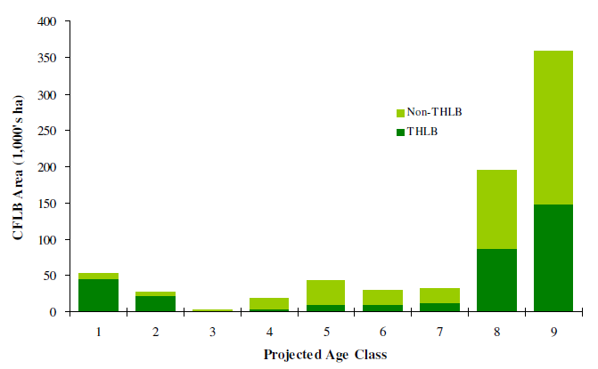
The 13.1 million Ha Cassiar TSA is characterized by mountains and plateaus separated by wide valleys and lowlands. The western part of the TSA consists of rugged mountains dissected by major river valleys including the Taku, Tatshenshini, Stikine and Iskut Rivers.
Boreal White & Black Spruce (BWBS), Spruce-Willow-Birch (SWB), and Engelmann Spruce-Subalpine Fir (ESSF) biogeoclimatic (BEC) zones dominate (53%, 29%, and 7%, respectively). Interior Cedar-Hemlock (ICH), Coastal Western Hemlock (CWH), and Sub-Boreal Spruce (SBS) zones are also present.
Approximately 81 percent of the TSA is non-forest (e.g., icefields), non-productive and non-commercial forests, parks and ecological reserves. Both the 2.5 million hectare CFLB and the 210,680 hectare THLB are dominated by pine and spruce, with subalpine fir additionally dominant in the CFLB. The THLB age class distribution skews towards younger age classes in interior BEC zones, and towards older age classes in coastal zones.

